Relational Databases with MySQL Week 4 Coding Assignment

**Points possible:** 70

|  |  |  |
| --- | --- | --- |
| Category | Criteria | % of Grade |
| Functionality | Does the code work? | 25 |
| Organization | Is the code clean and organized? Proper use of white space, syntax, and consistency are utilized. Names and comments are concise and clear. | 25 |
| Creativity | Student solved the problems presented in the assignment using creativity and out of the box thinking. | 25 |
| Completeness | All requirements of the assignment are complete. | 25 |

**Instructions:** Using a text editor of your choice, write the queries that accomplishes the objectives listed below. Take screenshots of the queries and results and paste them in this document where instructed below. Create a new repository on GitHub for this week’s assignments and push this document, with your Java project code, to the repository. Lastly, in the Learning Management System, click the “Add Submission” button and paste the URL to your GitHub repository.

**Coding Steps:**

Write 5 stored procedures for the employees database.

Write a description of what each stored procedure does and how to use it.

Procedures should use constructs you learned about from your research assignment and be more than just queries.

**Screenshots:**

This first procedure returns the number of employees with a specific last name. To use it pass in the required parameter – the last name and the parameter that will be output @total_names.



This second procedure is a simple procedure two parameters one IN and one OUT. It takes in the employee number and returns the corresponding date of birth for that unique employee



This third procedure is slightly more complex. It takes in one input employee number and outputs if an employee is male. Here I declared a variable and used a simple if statement. If an employee has a gender of M for male it returns the result ‘Employee is Male’ If the employee is female it will return is female .

The third procedure uses case statements. It takes an input of the department number and outputs the number of weeks of vacation that that department will have. Case statements are a slightly more readable alternative to IF statements.

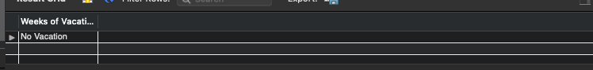

The fifth procedure takes an input employee number and returns whether than employee number starts with an A . To use it follow the same procedure use the CALL statement followed by the procedure name and the parameters. The out parameter should be preceded by the @symbol

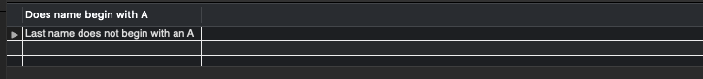

**URL to GitHub Repository:**